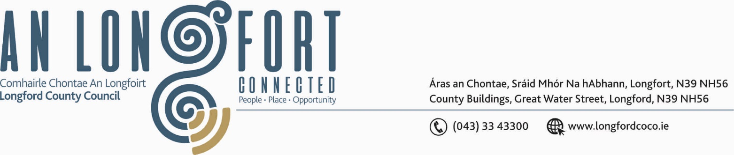

GRANARD MUNICIPAL DISTRICT

Please note meeting will be held via Microsoft Teams.

20th January 2021.

To: Each Member of Granard Municipal District.

Dear Member,

You are requested to attend Meeting of Granard Municipal District to be held
via Miscrosoft Teams on Tuesday, 26th January 2021 at 3.30 p.m.
to transact business, as set out on the Agenda hereunder.

Yours sincerely,
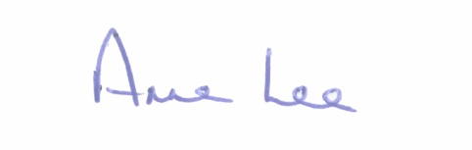

_______________
Anne Lee,
Meetings Administrator.

AGENDA

Prayer before meeting.

1. Confirmation of Minutes of the following Granard Municipal District Meetings -
(i) Committee MD Meeting held on the 24th November 2020
(ii) November MD Meeting held on the 24th November 2020.
- copies enclosed

2. Matters arising from Minutes.

3. Declaration of Interest by Members.

4. Management Report incorporating Area Engineer’s Progress Report
- enclosed.

5. Granard Public Art Features.

6. Consideration and adoption of Draft Municipal District Report for inclusion in
Longford County Council 2020 Annual Report – enclosed.

- Request received from The Irish Cancer Society to light up landmarks and public buildings yellow on the 26th March 2021 - Annual Daffodil Day – to heighten awareness of Daffodil Day Campaign – correspondence enclosed.

8. Notices of Motions, submitted by Councillors, as listed hereunder –

Councillor Colin Dalton.

“I am calling on Longford County Council to allocate funding for works at
St. John’s Church and Graveyard in Ballinalee.



